### Title Page

**Title**: Analysis of the Different Mental Health Disorders  
**Author**: Oyedele Ayomide  
**Date**: 17/09/2024

### Executive Summary

* **Purpose**:  
  The purpose of this project is to analyze various mental health disorders to understand their prevalence, symptoms, and the treatment options available. The goal is to highlight how these disorders affect individuals and to identify any gaps in public awareness and treatment.
* **Key Findings**:
  1. Anxiety disorders and depression are the most prevalent mental health conditions globally, with a significant overlap in their symptoms.
  2. Bipolar disorder and schizophrenia are less common but are often associated with more severe symptoms, significantly impacting daily functioning.
  3. Treatment availability varies widely, with cognitive behavioral therapy (CBT) and medication being the most common forms of treatment across disorders.
* **Recommendations**:
  1. Increase awareness of less common mental health conditions, such as personality disorders and psychotic disorders.
  2. Expand access to mental health resources, particularly in regions with limited mental healthcare infrastructure.
  3. Encourage early diagnosis and intervention to prevent the worsening of symptoms in individuals with mental health conditions.

### Introduction

"State of well-being in which the individual realizes his or her abilities, can cope with the normal stresses of life, can work productively and fruitfully, and can contribute to his or her community" is how the World Health Organization (WHO) defines Mental Health.

Mental health disorders, however, have not always been given the attention they deserve. Historically, certain conditions like depression and anxiety have been more widely recognized, while others, such as schizophrenia or personality disorders, are often misunderstood or stigmatized.

In this project, various types of mental health disorders are analyzed, exploring how frequently they occur relative to one another, their symptoms, and the treatment options available. This helps in understanding how they impact individuals and in identifying opportunities for improved mental health care.

* **Objectives**:
  1. To understand the different types of mental health disorders.
  2. To analyze the symptoms associated with these disorders.
  3. To evaluate the available treatment options for these disorders.
* **Scope**:  
  This analysis provides insights into common mental health disorders and offers statistical evidence on their impact and treatment methods. However, the project does not dive into niche or rare disorders that have limited data.

### Data Description

* **Data Sources**:  
  The dataset analyzed for this project was sourced from Kaggle, a platform offering a variety of datasets for machine learning and data analysis.
* **Preprocessing Steps**:  
  The dataset required minimal preprocessing as it was mostly clean and well-structured. Columns were properly named, and only minor adjustments were made to ensure consistency in naming conventions and data formatting.

### Methodology

* **Analysis Techniques**:  
  The analysis was performed using Python programming language, with the use of libraries such as Pandas for data manipulation, NumPy for numerical operations, and Matplotlib for data visualization.
* **Reasoning**:  
  Python is a versatile language that allows for highly customizable and detailed data analysis. The use of these libraries facilitated an in-depth understanding of the dataset, enabling clear visualizations and data insights.
* **Validation**:  
  A t-test was applied to statistically validate the findings from the data analysis. This helped confirm any significant relationships between variables, such as the connection between certain disorders and the effectiveness of their treatment options.

**6. Results**

* **Findings:** Seven different dataset was analyzed. Certain disorders were observed in this analysis and in order to understand the correlations, heatmap was utilized. From the first heatmap it was discovered;
  1. Bipolar disorders and Eating disorders have a positive correlation of 0.68
  2. Eating disorders and Anxiety disorders also have a positive correlation of 0.59
  3. Depressive correlation and Eating disorders have a negative correlation of -0.052
  4. Schizophrenia disorders and Eating disorders have a positive correlation of 0.5

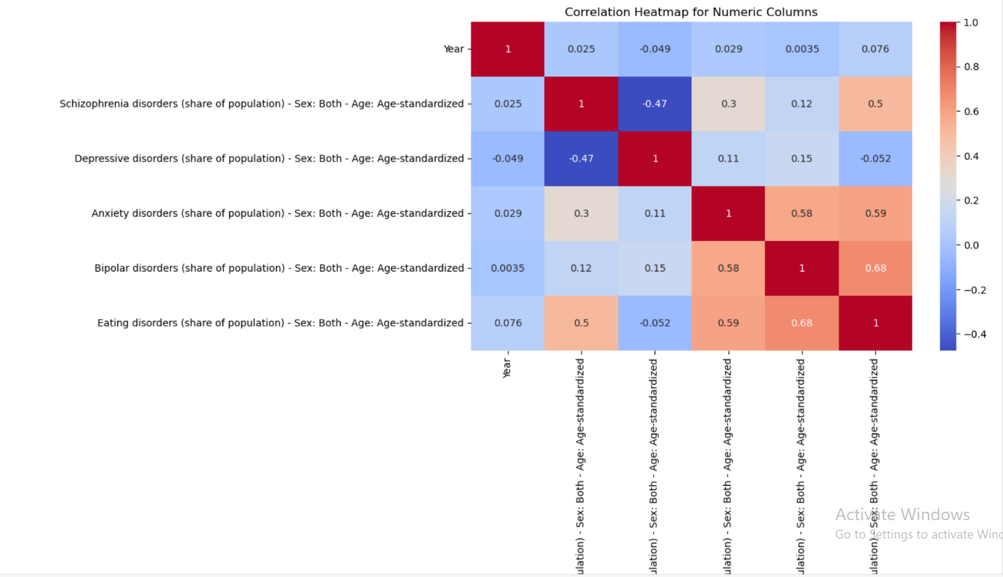

In order to properly understand the correlations observed with the heatmap, a bar chart was plotted.

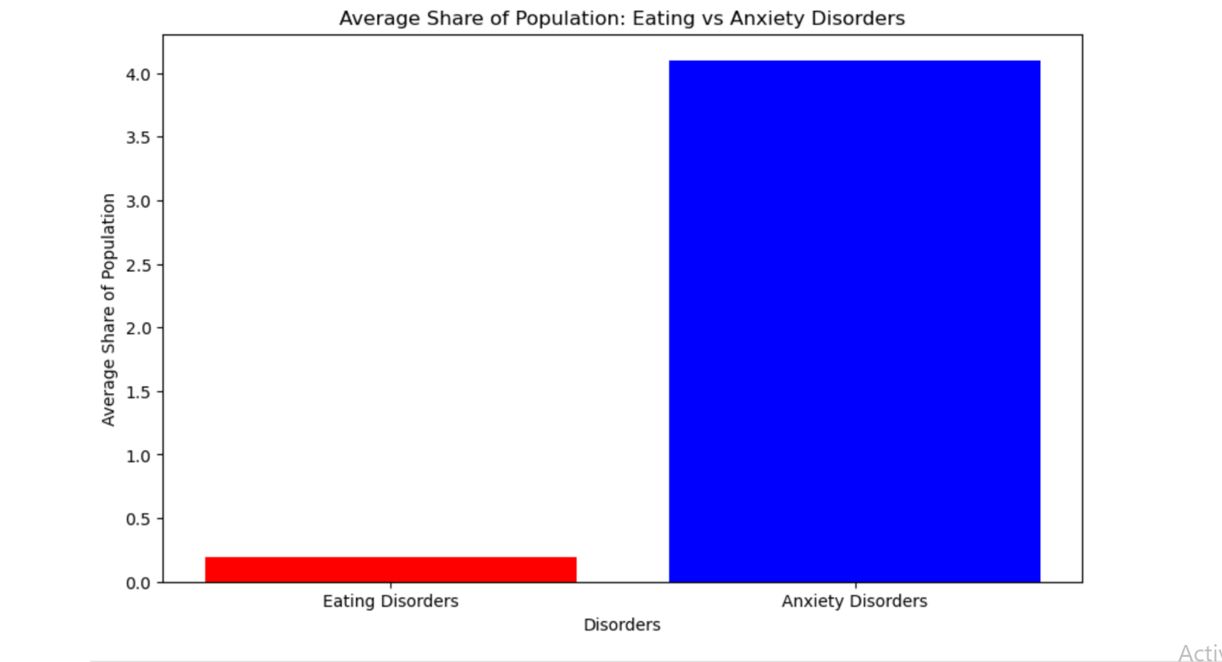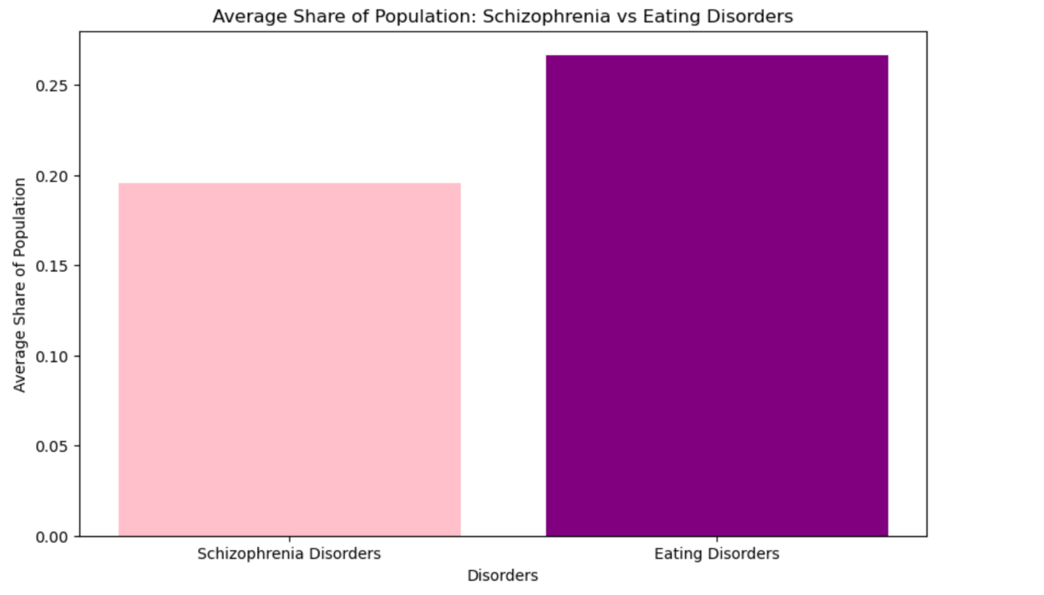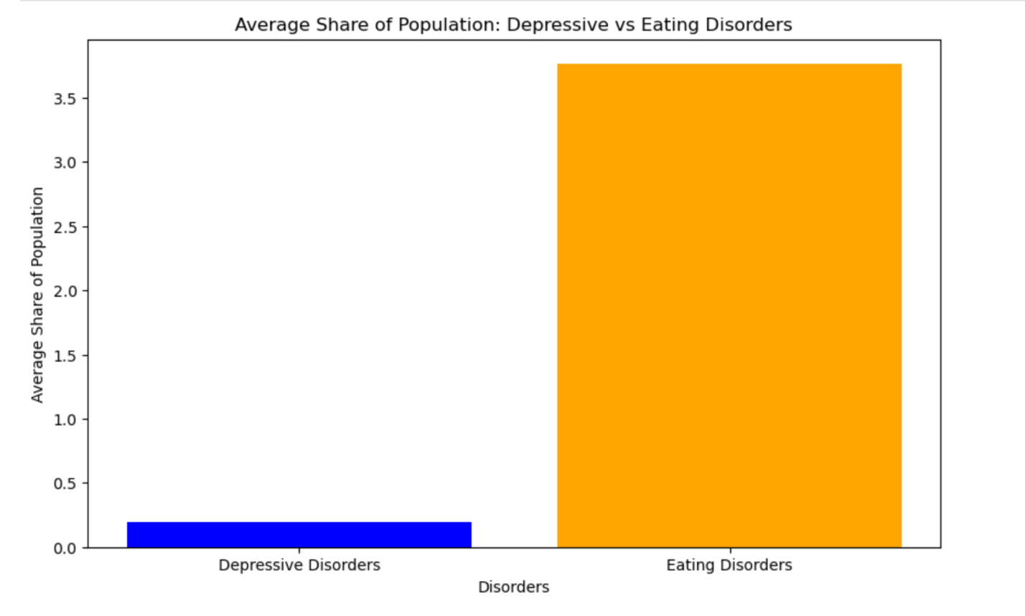

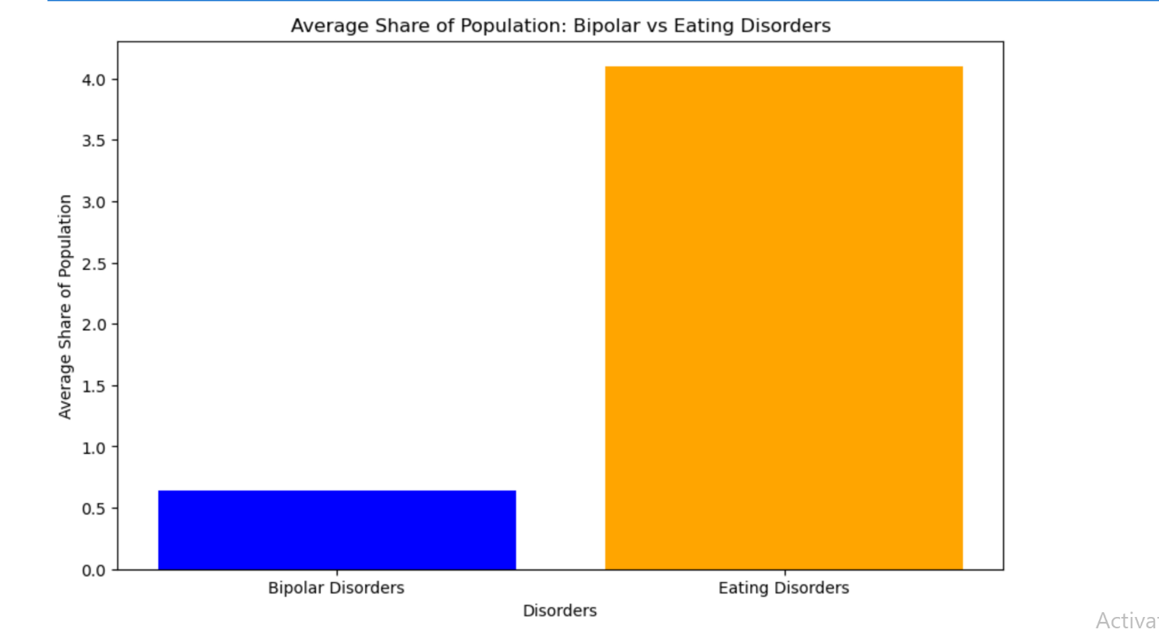

Another dataset which contained the DALYS(rate) of these disorders was also observed and these were the key findings;

1. Anxiety and Eating disorders have a positive correlation of 0.6
2. Anxiety and Bipolar disorders have a positive correlation of 0.58
3. Eating and Schizophrenia have a positive correlation of 0.48
4. Bipolar and Eating disorders have a positive correlation of 0.68
5. Anxiety and Depressive disorders have a negative correlation of 0.16
6. Anxiety and Schizophrenia have a negative correlation of 0.29
7. Year has a negative correlation with all the mental health disorders

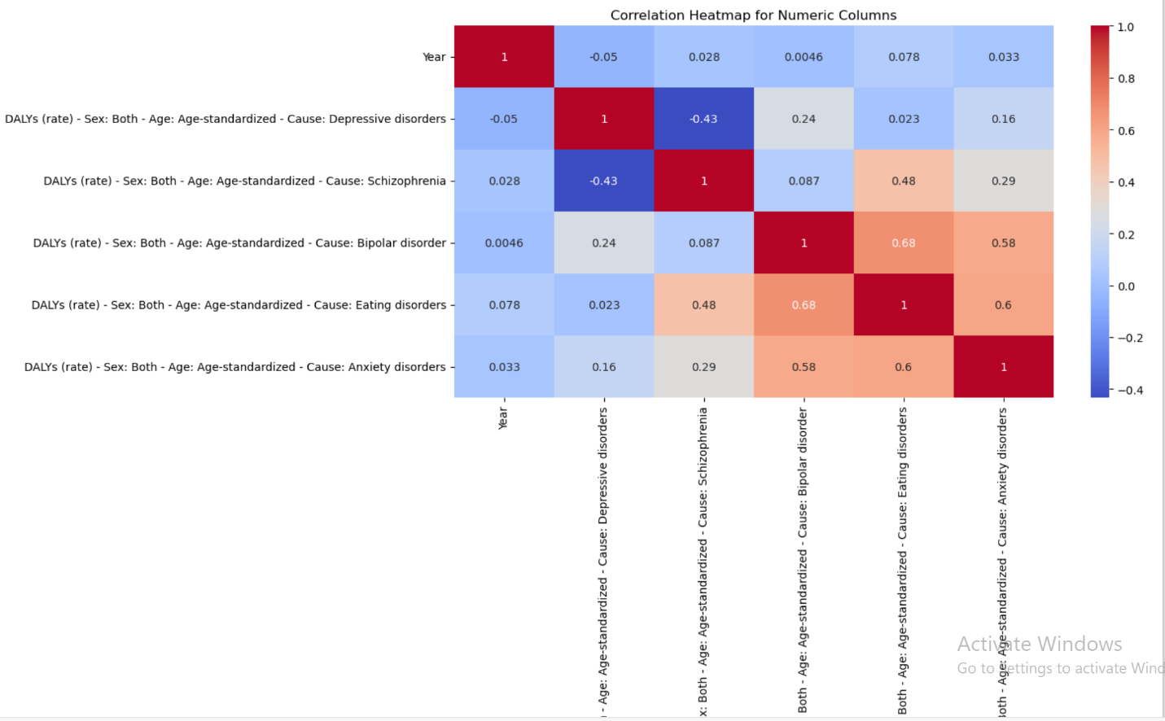

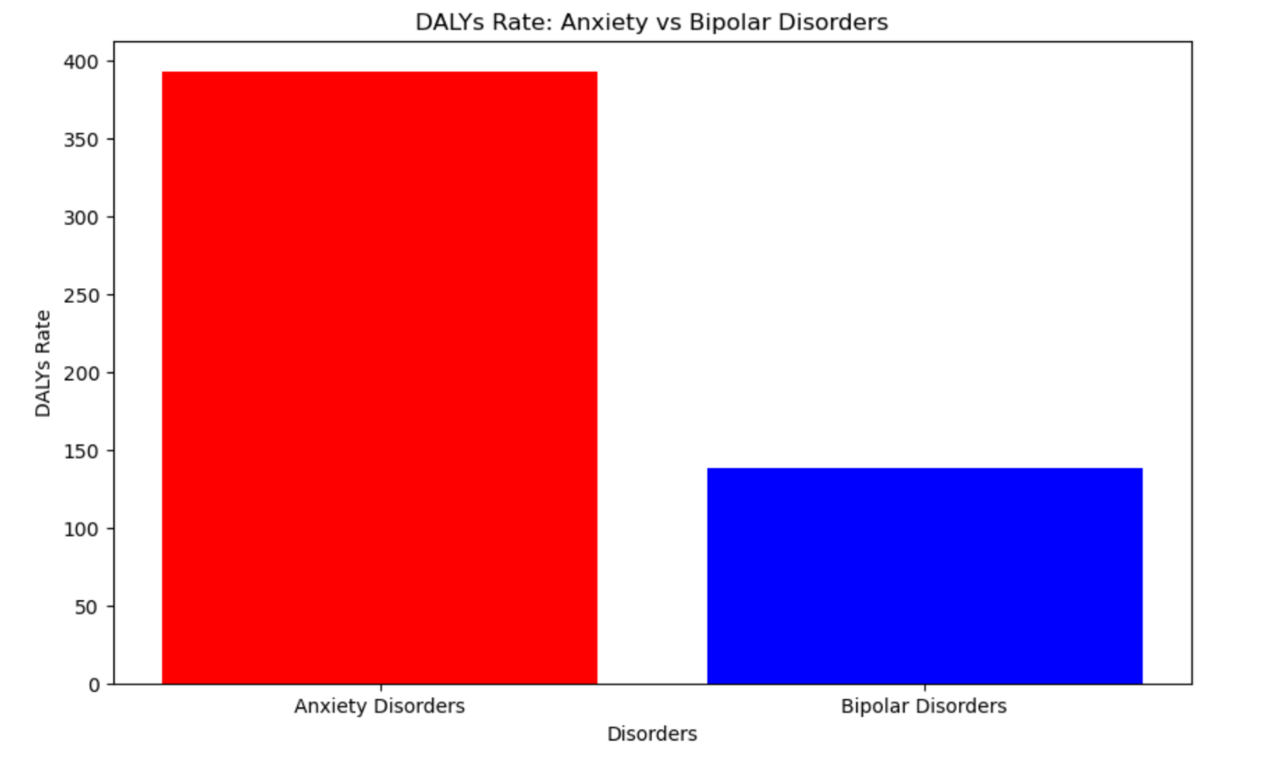

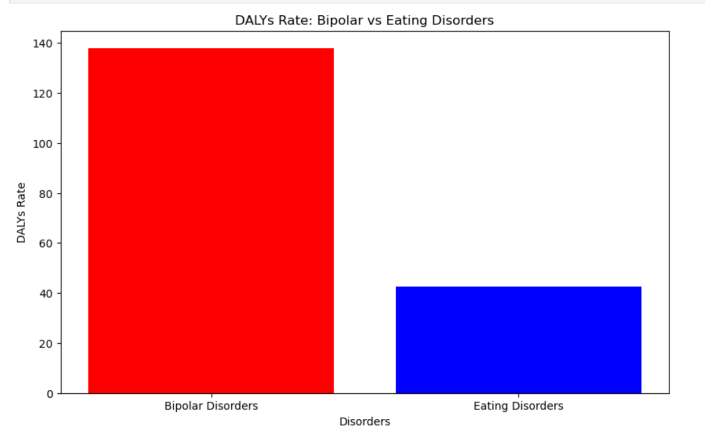

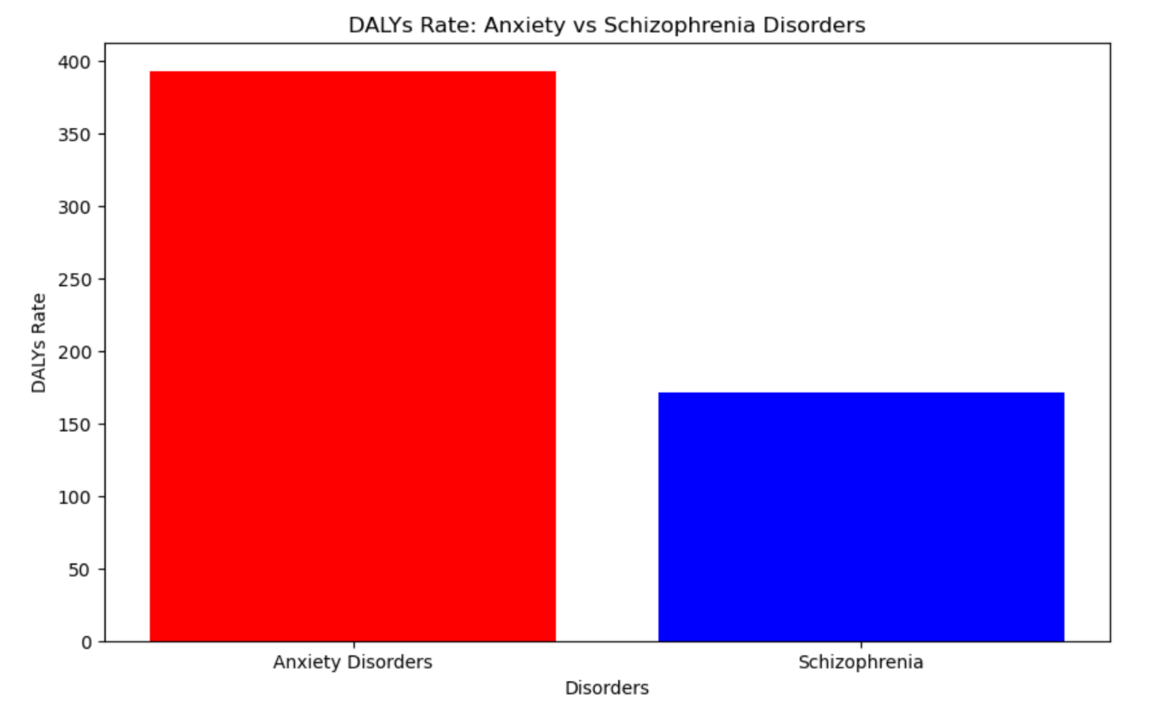

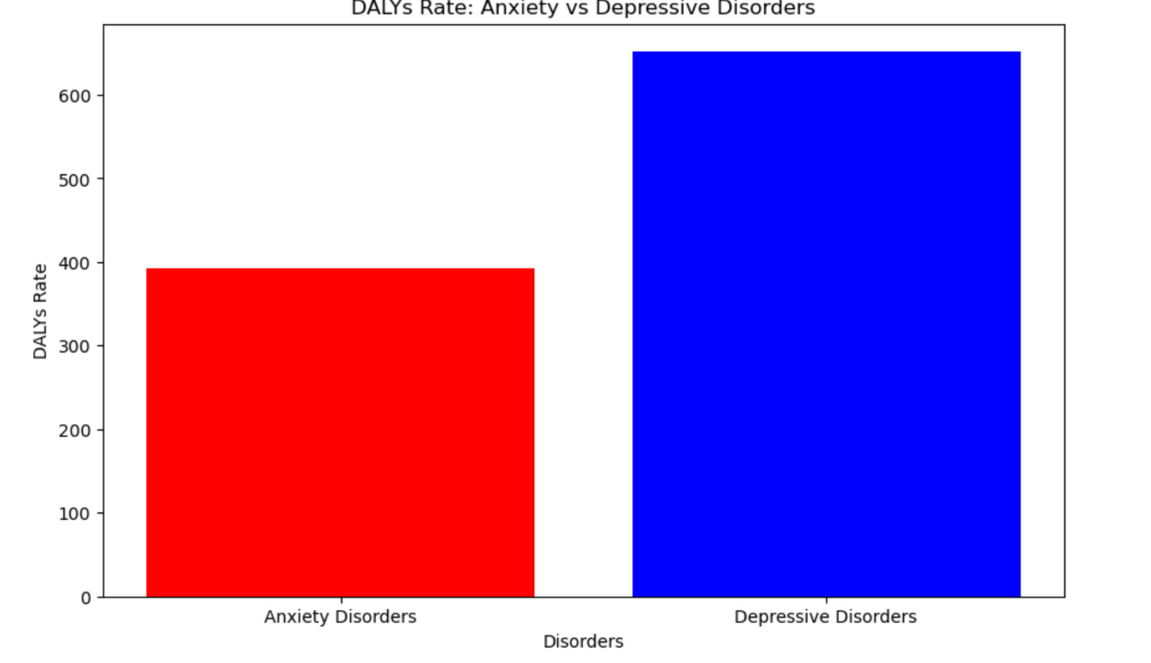

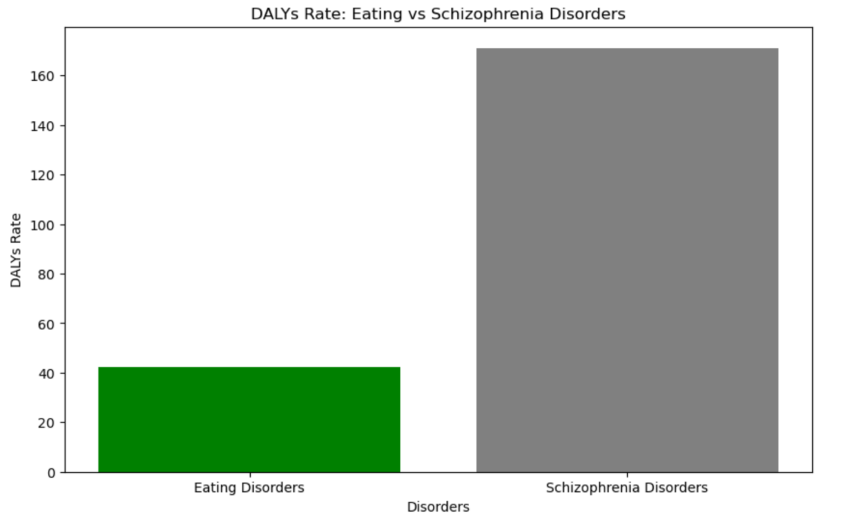

Another dataset was analyzed. This dataset contained the major depression rate over the years but from the image above. 2008 seemed to have a taken the hit of major depression

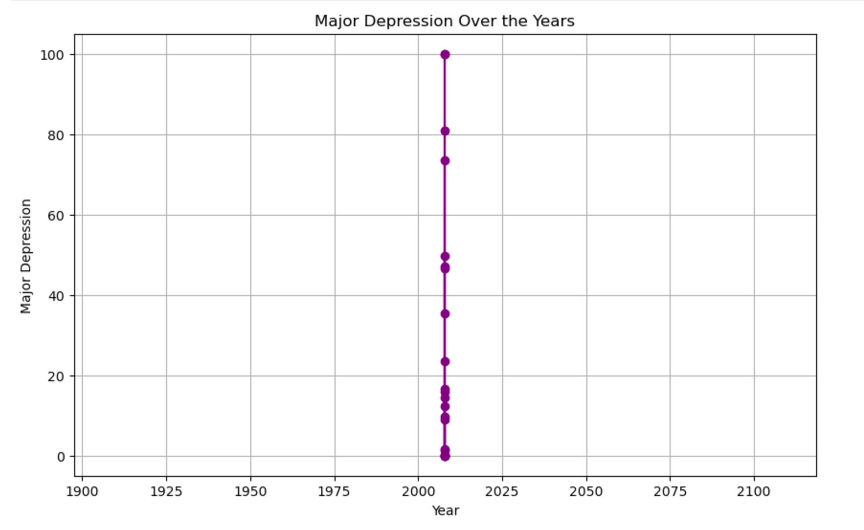

Another dataset was observed and these are the key findings

* 1. Major depression and Anxiety disorders have a positive correlation of 0.88
  2. Anxiety and Bipolar disorder have a negative correlation of 0.68
  3. Anxiety and Eating disorder have a negative correlation of 0.63
  4. Dysthymia and Anxiety disorders have a negative correlation of 0.65

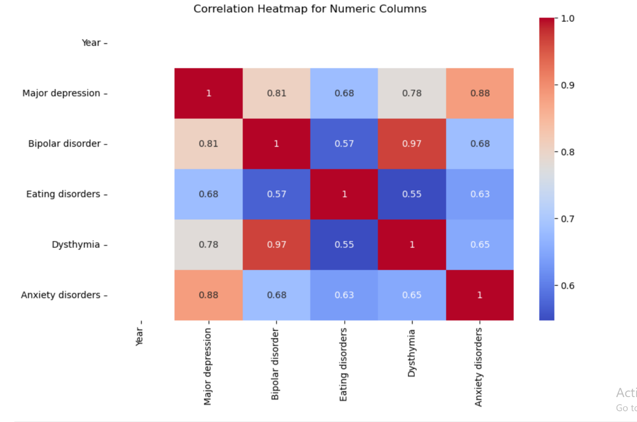

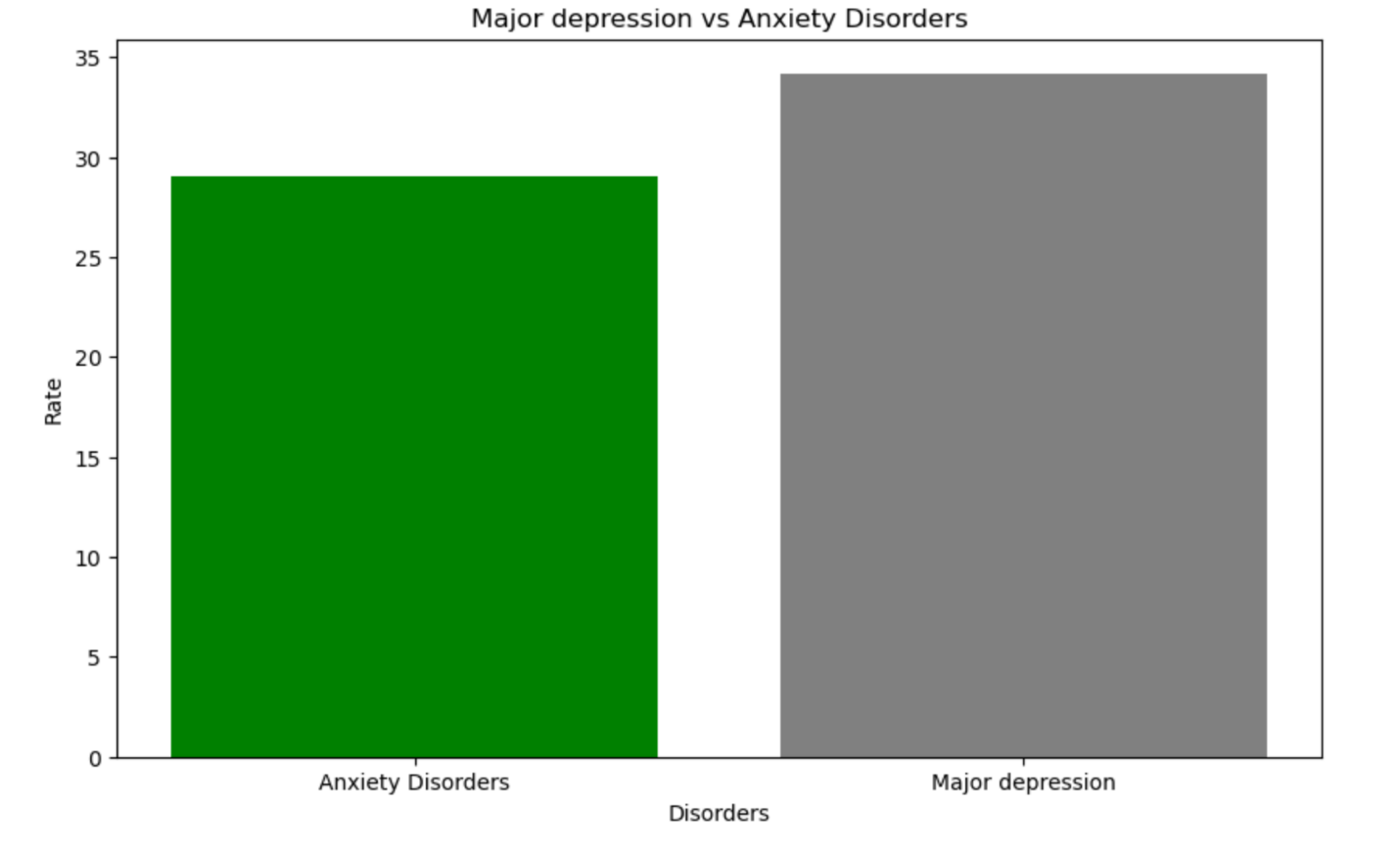

Only the positive correlation in this case was observed

Another dataset on the treatment conditions available was analysed.

These are the key findings;

* 1. 2003 had the highest potentially adequate treatment available with 2007 with the lowest
  2. Years 2010, 2011, 2013,2014, 2016 and 2018 couldn’t be accounted for in potentially adequate treatment
  3. Year 2012 took the hit in other treatments available and 2007 had the lowest
  4. We can observe that the years in the untreated treatments graph below all had significant high rate but year 2003 takes the most

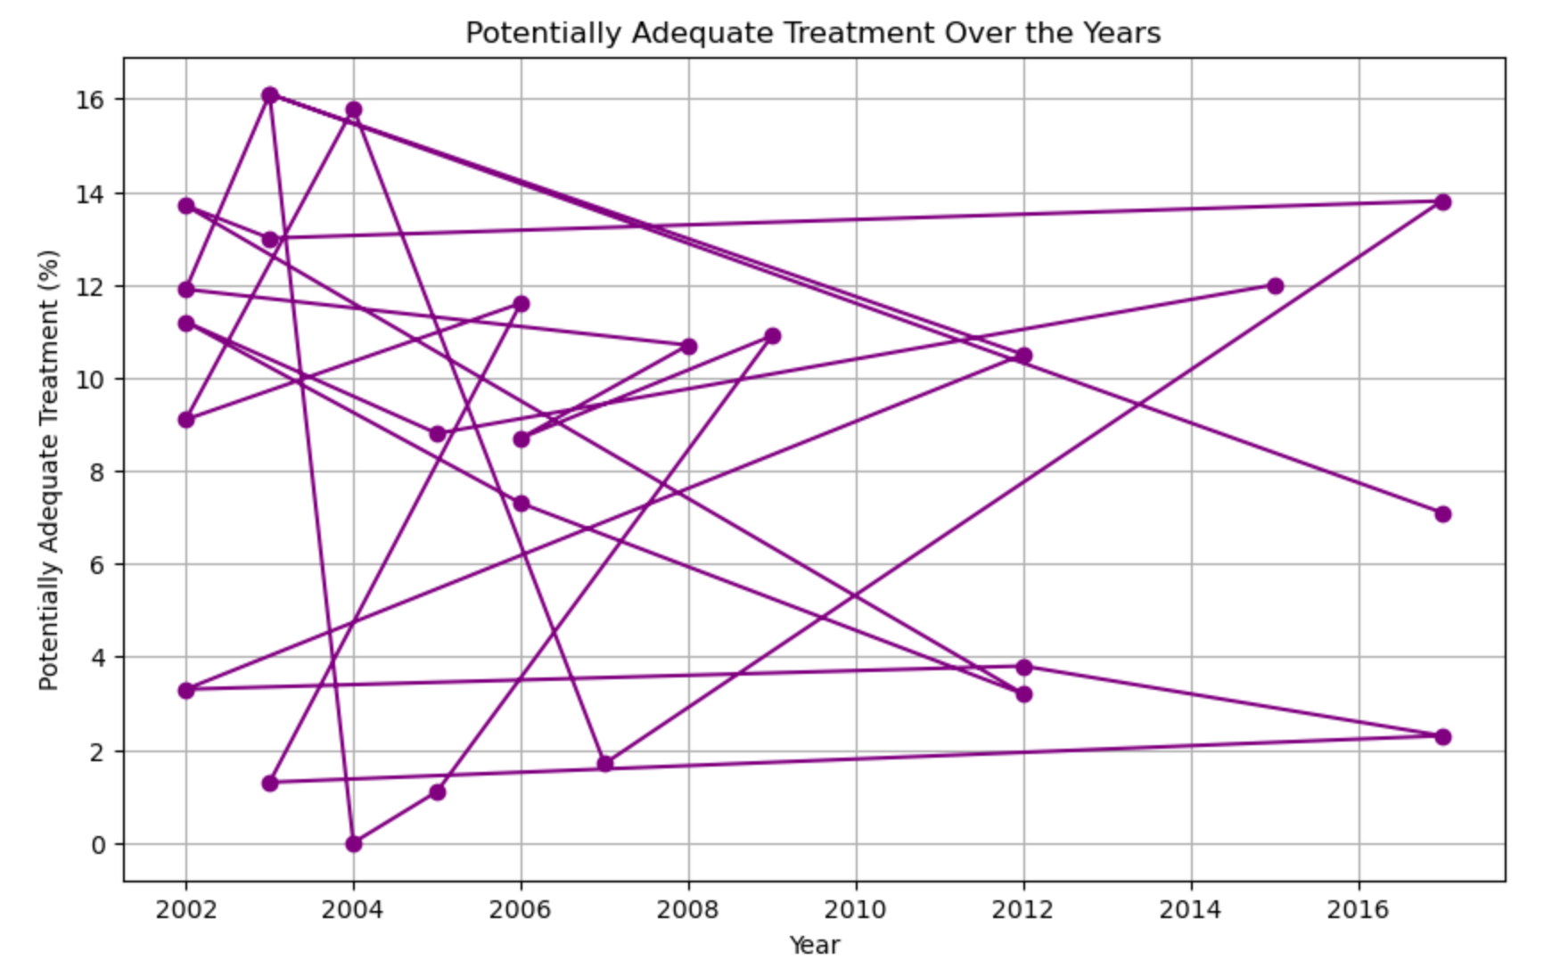

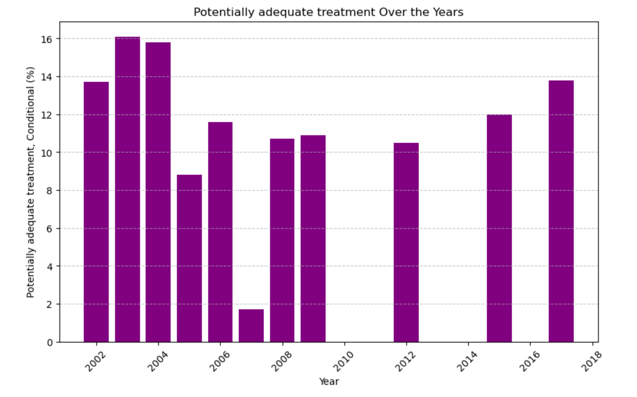

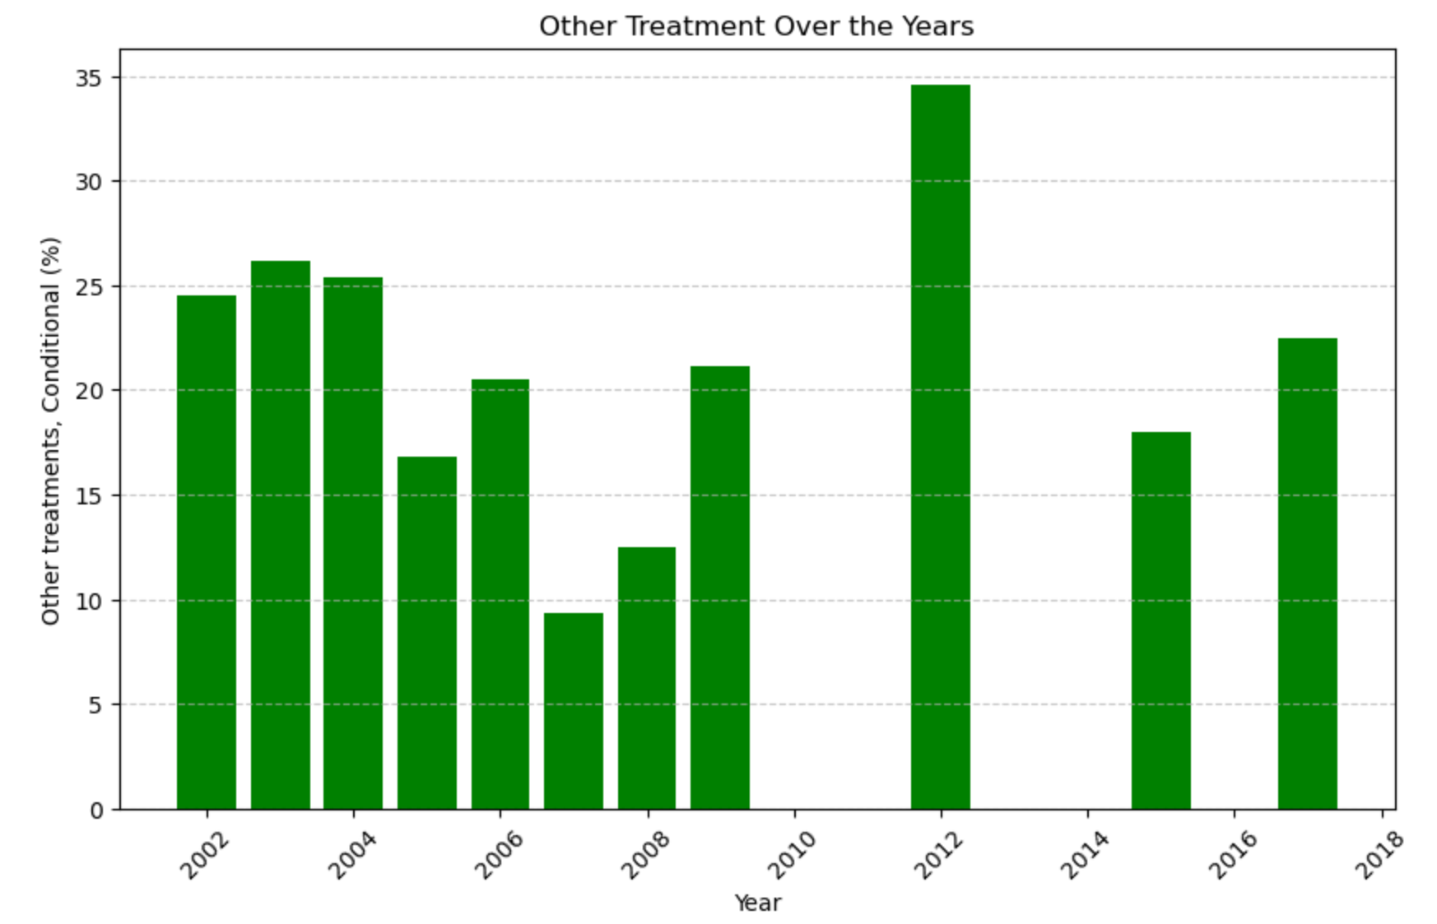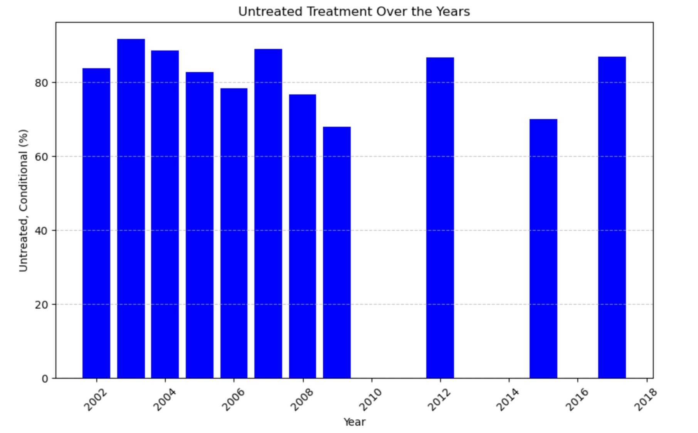

I also took this analysis deeper by understanding the different symptoms and frequently it is experienced by people who suffer from mental health disorders. The key findings include;

1. A symptom commonly experienced more than half of the day is low energy then sleep problems. Suicidal ideation seemed to have a very low chance of being experienced
2. Nearly everyday symptoms is sleep problems and low energy
3. Several days symptoms also had the same symptoms as more than half of the day and nearly everyday
4. Not at all symptoms were suicidal ideation, psychomotor agitations

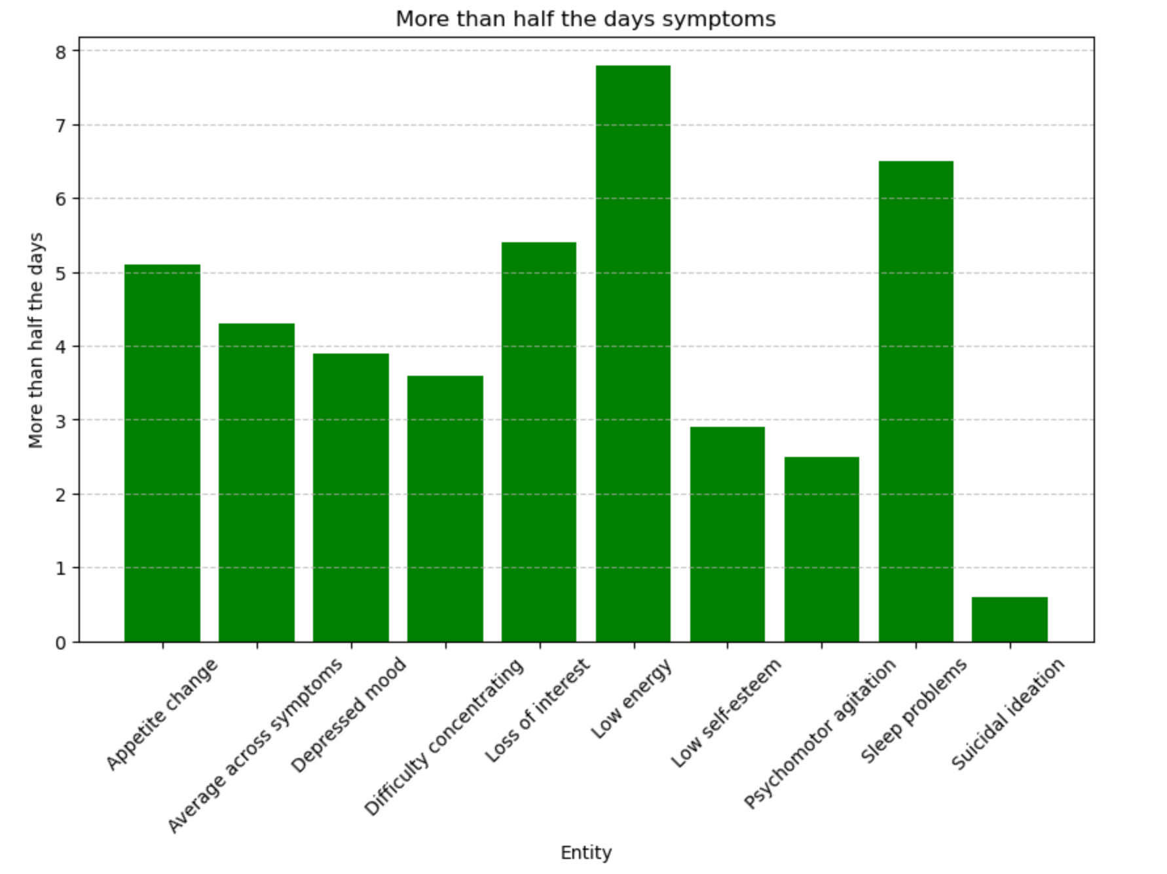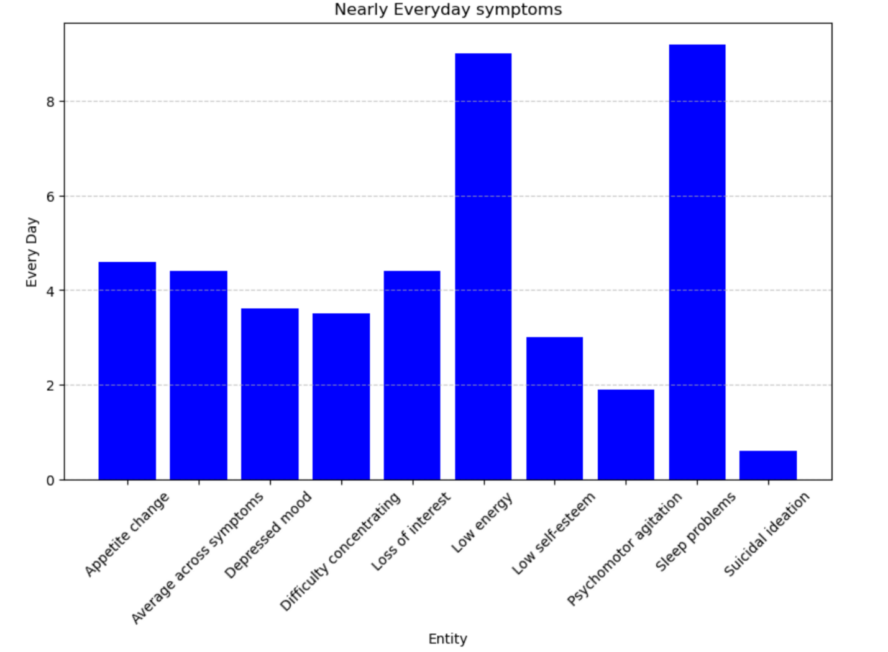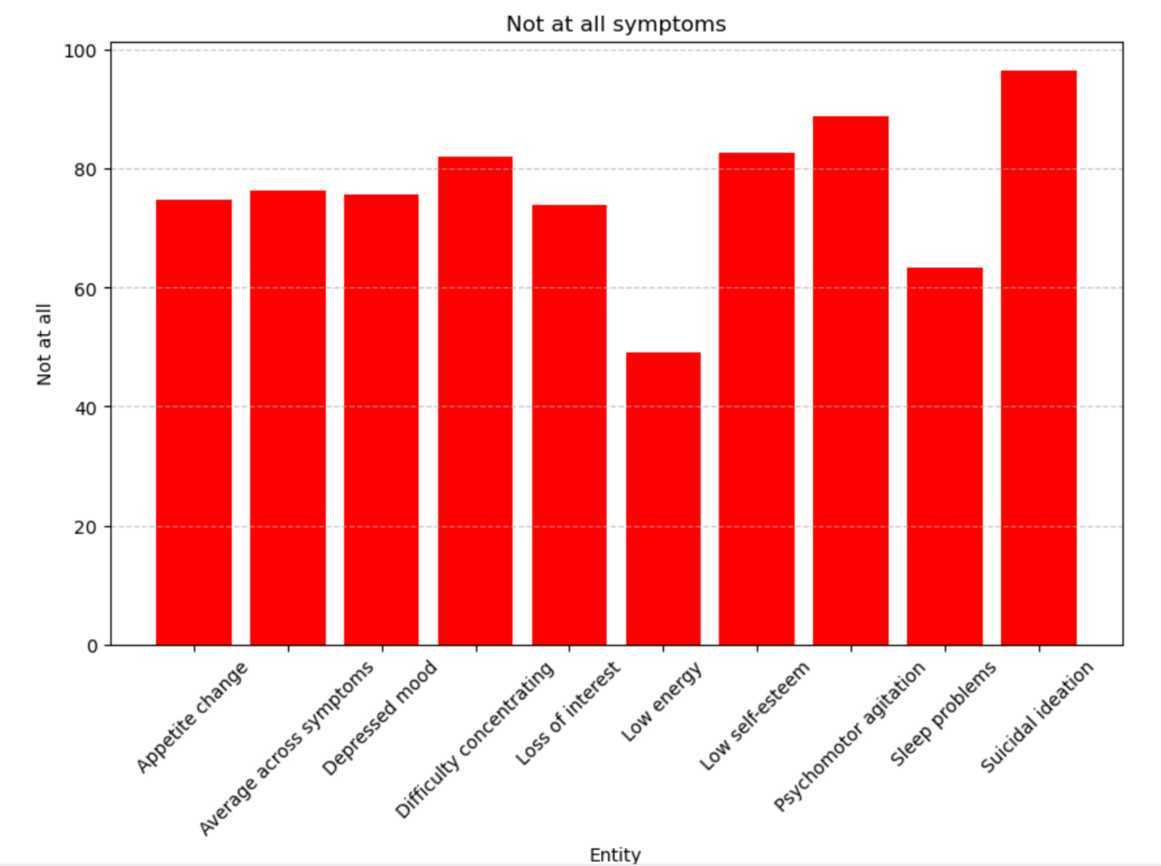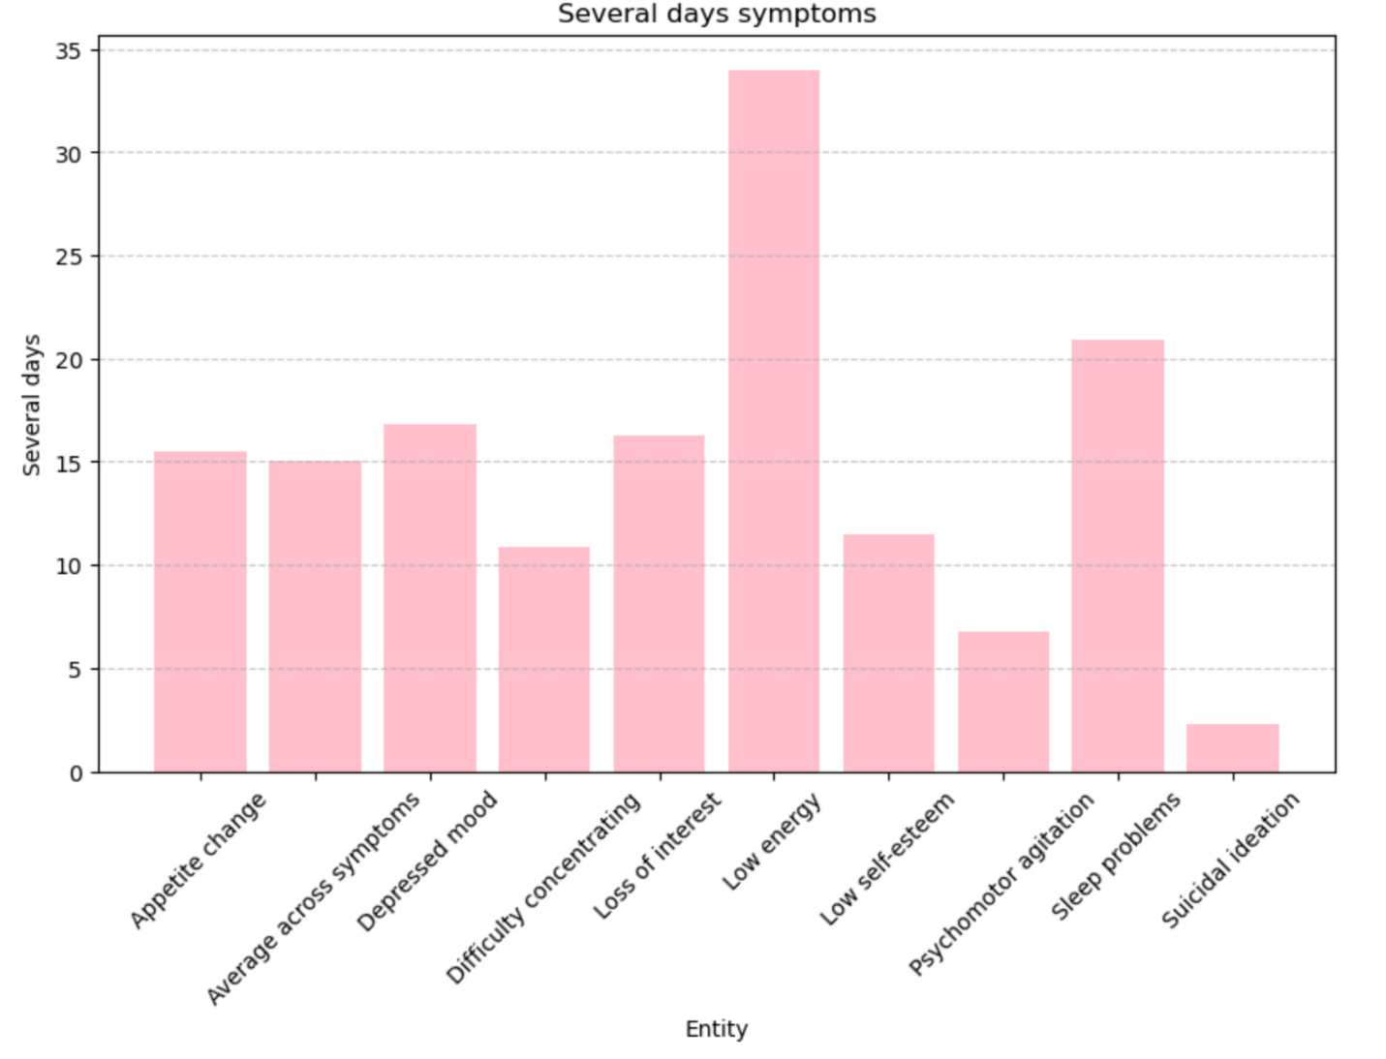

From the graph below Attention-deficit hyperactive disorder seemed to be more common in different countries followed by Cannabis use disorder then Major depressive disorder taking the third place. Other drug use and personality disorders seem to be the lowest common disorders.

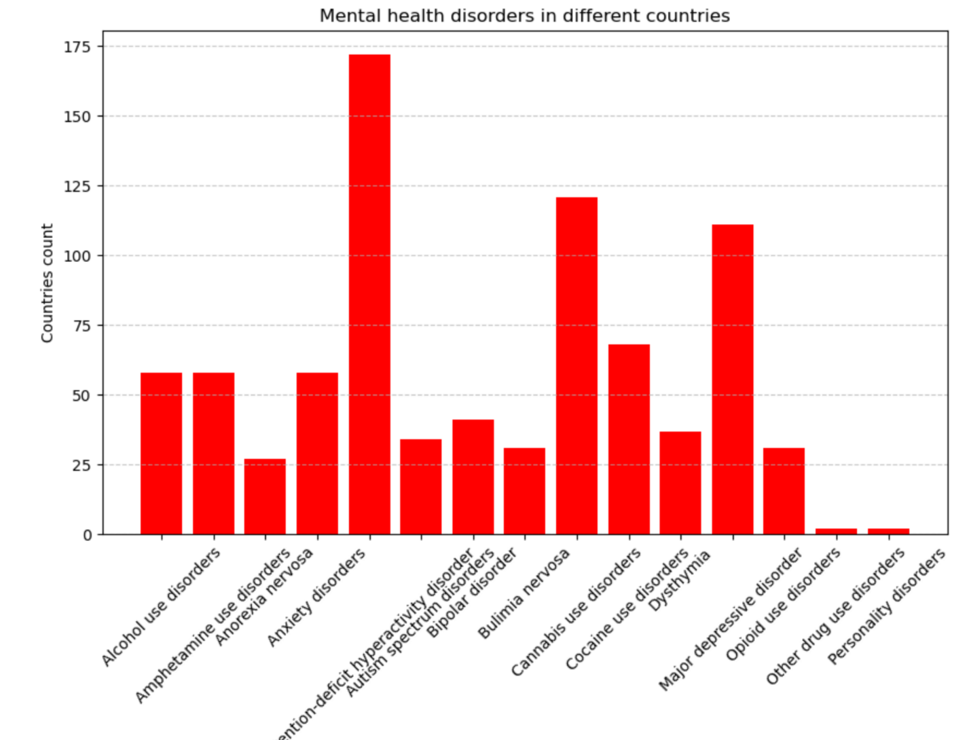

* **Interpretation:** What the results mean in the context of mental health.
* **Patterns and Trends:** Notable observations or correlations.

**7. Discussion**

* **Implications:** How the findings impact the understanding of mental health.
* **Limitations:** Any constraints or issues that may affect the analysis.
* **Comparison:** How your findings align with or differ from existing research.

**8. Recommendations**

* **Actions:** Specific steps or interventions based on the analysis.
* **Future Research:** Suggestions for further investigation.

**9. Conclusion**

* **Summary:** Recap of key findings and their significance.
* **Final Thoughts:** Any concluding remarks or reflections.